Reoccurring Monthly Donation Set-up

Donate: checkout experience
The donate experience begins when a donor clicks the Donate button on our website. www.elotw.com
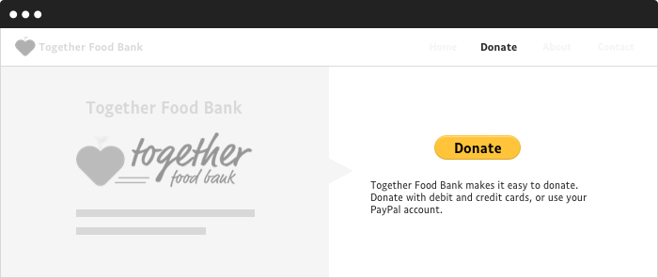
When the donor clicks the Donate button, PayPal displays the donate landing page.
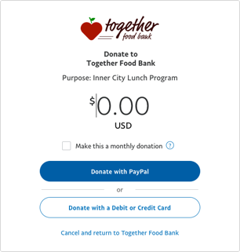
On this page, the donor can:
- Enter the donation amount or verify the amount designated from your donate button.
- Click the Make this a monthly donation checkbox to make this donation a recurring gift.
- Click Donate with PayPal or Donate with a Debit or Credit Card.

Paying with PayPal
If the donor logs in to PayPal, the review page is displayed.

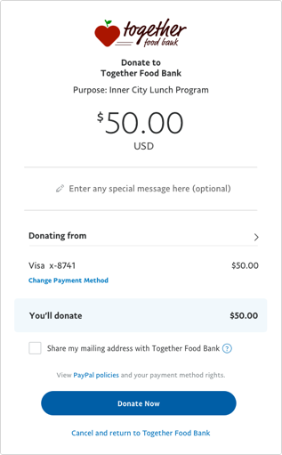
The donor can verify the donation amount and payment details or change the payment method. The donor can also choose to share their mailing address with the organization. When the donor clicks Donate Now, the payment is authorized and PayPal displays a confirmation page.
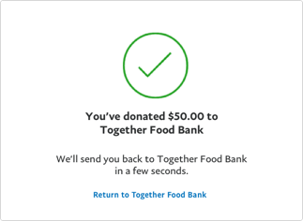Finally, PayPal sends the donor an email to confirm the transaction.

Paying with debit or credit card
If the donor chooses to pay with a debit or credit card, the guest donation form opens.
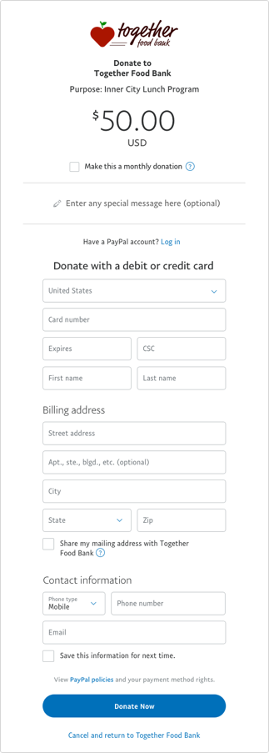
The donor can:
- Enter debit or credit card information.
- Enter billing and contact information.
- Optionally, make this a recurring monthly donation.
- Optionally, create a PayPal account.
When the donor clicks Donate Now, the payment is authorized and PayPal displays a confirmation page.
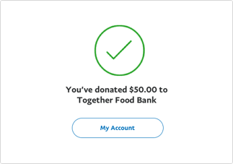Finally, PayPal sends the donor an email to confirm the transaction.

How do I cancel a Billing Agreement?
Use the following steps to cancel a Billing Agreement:
- Click Settings at the top of the page.
- Click Payments.
- Click Manage pre-approved payments.
- Select the merchant's name or email address.
- Click Cancel.
If the payment has already completed, you can request a refund from the seller.

